Xray Test Management
Xray is a test management tool built natively into Jira that enables teams to manage both manual and automated testing efficiently. It is designed to support Agile and DevOps practices by providing full traceability between requirements, test cases, test executions, and defects.
Unlike external test management tools, Xray integrates seamlessly with Jira issues, allowing teams to work within a single ecosystem. It is widely used in Agile projects to support continuous testing, sprint-level execution tracking, and visibility into release quality.
Xray extends Jira’s default issue types by introducing specialized test management entities, including Test, Test Execution, Test Plan, and Test Set, enabling structured and scalable test management across the software development lifecycle.
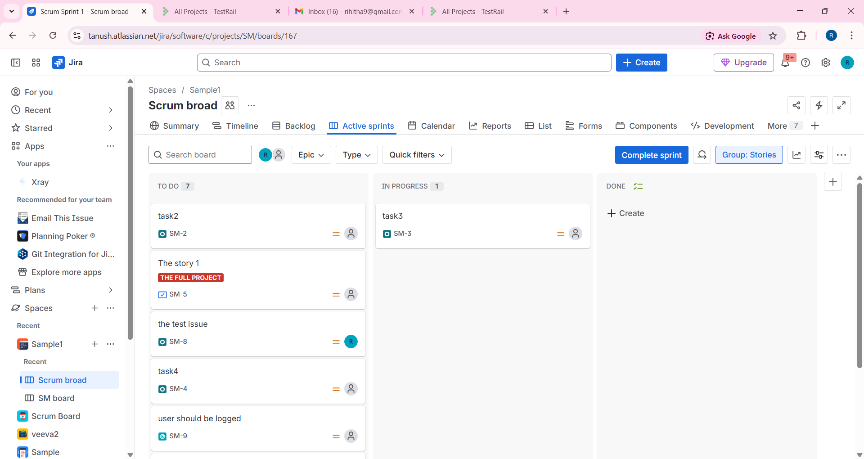
Jira Story
A Story is a Jira issue type used to describe a user-facing requirement or feature from a business or end-user perspective. It represents what needs to be built and why.
Key characteristics:
- Captures functional or business requirements
- Written from the user’s point of view (user stories)
- Planned and tracked within sprints
- Linked to tasks, bugs, and test cases
- Focuses on delivery of value
Xray Test Issue
A Test is an Xray-specific issue type used to define a test case that verifies one or more requirements (such as Stories). It represents how the functionality will be validated.
Key characteristics:
- Defines manual or automated test cases
- Contains test steps, test data, and expected results
- Can be reused across multiple stories, sprints, and releases
- Executed via Test Executions
- Provides traceability to requirements and defects
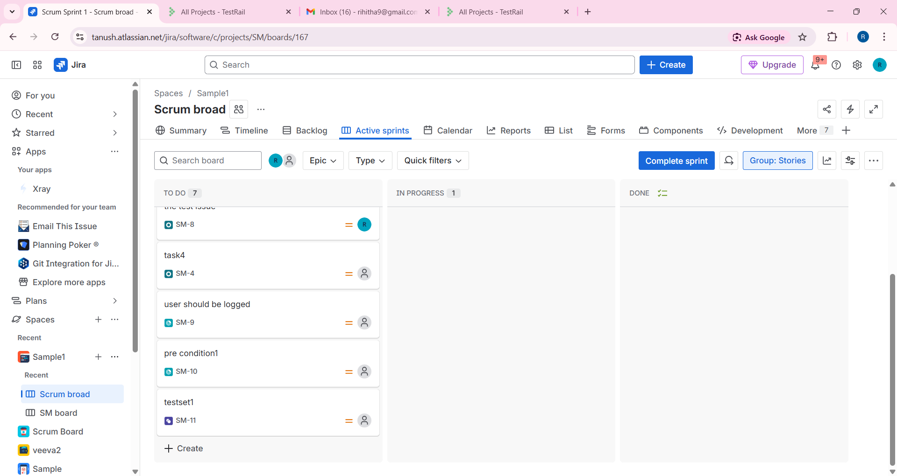

Xray Architecture
